Features

Documentary film explores role of Oyler School in 'saving' Lower Price Hill
HANNAH PURNELL | TUESDAY, MAY 12, 2015
Amy Scott
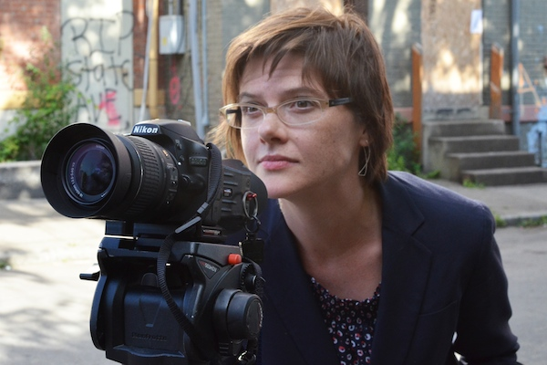

PROVIDED
SHARE
CINCINNATI, DIVERSITY,EDUCATION + LEARNING, FILM,HEALTH + WELLNESS,LEADERSHIP, QUALITY OF LIFE, TALENT,VOLUNTEER
PRICE HILL
When she arrived in Cincinnati on assignment for public radio’s Marketplace in 2012, education correspondent Amy Scott didn’t plan to spend the next two years detailing the lives of students and faculty members at Price Hill’s Oyler School. But that’s pretty much what happened.
The result is a documentary film that raises questions about the role of schools in historically embattled communities like Lower Price Hill, whose Urban-Appalachian residents are mostly low-income, white families with roots in Kentucky and West Virginia. Oyler will have its premiere public screening May 22 at the Mount St. Joseph University Theatre (ticket details here, see the trailerhere).
Scott’s film is an hour-long look at Cincinnati Public Schools’ community school model that emphasizes services that go beyond academics: basic health, vision and dental care; after-school programs; mental and emotional counseling; and, in some cases, enough food to last hungry families through evenings and weekends.
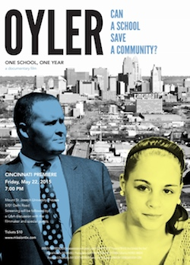
“Can a school save a community?” quickly emerged as the film’s tagline, Scott says, inspired by the attempts of Oyler’s then-principal, Craig Hockenberry (pictured on the movie poster), to turn around the school.
“That (tagline) was how we boiled down what Oyler was trying to do,” Scott says. “Not only for the school, but for the neighborhood and the streets surrounding the school. So my question was: Can a school really do that? Can it help its neighborhood to overcome some really serious challenges?”
For film audiences, those questions spring to life through the story of Oyler student Raven Gribbins (also pictured on the movie poster), who seeks to become the first in a family plagued by addiction and poverty to graduate high school and go to college.
Final post-production work on Oyler was completed after a Kickstarter campaignlast summer raised a total of $29,181. Additional public screenings are planned for the Baltimore and Los Angeles markets, with other cities to follow. The filmmakers are also pursuing television broadcast.
Scott, who will host a Q&A panel along with Hockenberry and Gribbins following the May 22 screening, talked to Soapbox about her reasons for making the film, her role as documentarian and the response she hopes the film will elicit.
How did the community schools movement start, and how seriously is it being taken on a national scale? What made you hone in on Oyler School a potential national example?
Amy Scott: The community-schools movement has been around for a long time, and there are many cities that could probably model it, but I had personally never witnessed it. One of my stories was about (Oyler) opening a vision clinic on site. When I described it after visiting, I said it looked like a LensCrafters inside of a school. That’s not the kind of school I went to and not the kind of school you see every day, so that struck me. All the services going on inside that building are not what we typically associate with schools.
Half of the children in our public schools come from low-income families, so given that our nation faces such struggle in educating our most vulnerable children, looking at one school — what’s working and what isn’t — can inform that national conversation.
How prepared did you feel going into the homes of Lower Price Hill families? What were your expectations, and what role did school administrators play in cultivating those relationships?
Scott: Through previous public radio assignments, I was somewhat familiar with Urban-Appalachian culture, but it wasn’t until I met Darlene Kamine (Executive Director for the Community Learning Center Institute) and she described the neighborhood that I really got a sense of the history and how unique it is.
Because of my background, I’m used to going into people’s homes and invading their privacy (laughs) and asking them to open up. I think that prepared me somewhat. But I really relied on the trust the community had for Principal Hockenberry. He and other staff members opened up a lot of doors for me … and vouched for me, so people were willing to open up.
A lot of people are suspicious of the media, and sometimes it’s justified, so I definitely felt a little bit of resistance in the beginning. But Mr. Hockenberry knew that he had a great story to tell and so he gave me sort of all-access to the school, and that really made the difference.
If this type of reporting can be a platform for change, what do’s and don’ts would you give to other documentarians hoping to shed light on community issues?
Scott: I take my role as a reporter extremely seriously in that my job is not to be an advocate — it’s to tell the story as I see it and to be as objective as possible. Obviously I’m human, so I come to conclusions and I have tendencies, but that can be tough when you’re working in a community like Oyler.
You become close to people and you need their trust to keep reporting, but occasionally you’ll see things that people may not really want recorded. I strived to tell the truth without sensationalizing anything or violating that trust — particularly of the young people involved — so that I could gain their respect as a reporter and keep my credibility intact.
What do you want viewers to take away from the film?
Scott: I don’t want to say too much because I don’t want to give away the ending of the film for people who aren’t familiar with the story. What I really hope is that it raises awareness of the challenges schools are facing and those that teachers face in preparing (students) for standardized tests and to think about whether our schools can and should provide for students beyond academics.
Should we assume the documentary concludes with a progress report of how this model is working for Oyler?
Scott: Um, no (laughs). I don’t think we make a conclusion about whether this works or not. That will be for the viewer to decide. What it raises is a question about how we judge success and who should be judging success.
PRICE HILL

Read more articles by Hannah Purnell.
Hannah Purnell is a marketer and freelance journalist who lives in Bellevue and writes about education, arts and business in Greater Cincinnati.\

