Donate

NOVEMBER 25, 2020

Grateful for our Community Heroes: See Our Flags by Hero Design Company
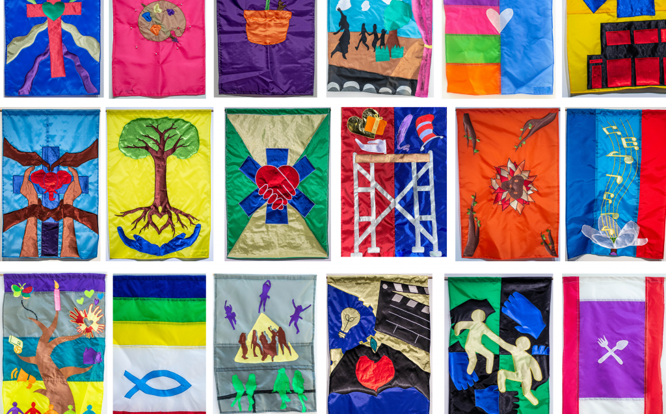

As we begin our celebrations for Thanksgiving and Native American Heritage Day, ArtWorks would like to thank our community’s heroes.
We are continually inspired by the giving and innovative spirit of our community to tackle challenges and create solutions to meet the needs of others. So earlier this year, we asked the community to nominate local heroes—those who are working behind the scenes using their talents, courage, creativity, and generosity to meet the many challenges our community has faced this year.
As part of the Hero Design Company, ArtWorks Youth Apprentices this summer designed and sewed custom one-of-a-kind flags while safe at home to honor and bring attention to local heroes whose selfless acts set them apart. The team was led by professional artist Lindsey Whittle.
Your response for nominating heroes was amazing! We created flags for as many as we could.
The team’s work was flown during on installation on Central Parkway in September. We are honored to share the nominations and images from this project with you.

Read the Stories of our Community Heroes

Kerissa Hicks
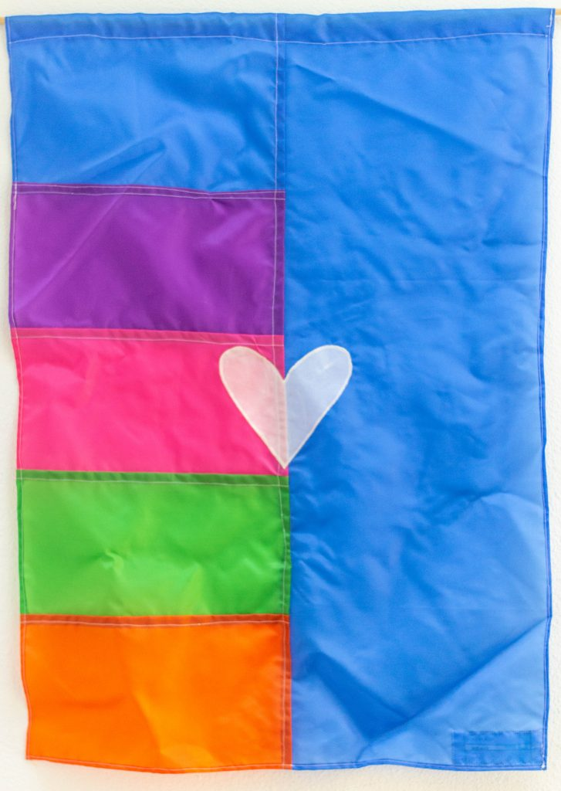
What our nominator wrote: “My community hero is Kerissa Hicks, a colleague and friend. She is the enrichment program manager at Roberts Academy, but does far more than just manage the enrichment for the students in the after-school program. Since COVID came to disrupt the daily routine of all of our daily lives, Kerissa, along with our entire team of our community learning center worked literally 12-hour days to pivot our work from in-person to a virtual platform. Kerissa has not only ventured into a new world of virtual enrichment, she has embraced it! She does a morning greeting each day, sometimes from her greenhouse in a banana suit, or showing how to build a giant tower with found objects in the house, or some fun, random place in her Captain Kerissa cape! She has texted, called, reminded hundreds of students and parents about the new Google platform and how to join. She has developed new connections and partnerships, asking and encouraging new ideas and innovating partners to invent fun and engaging ‘clubs’ to enrich the online learning experiences for ALL students. Kerissa is always willing to add to her plate by volunteering her thoughts and ideas by joining a committee or new coalition, adding her input to bolster the manner in which we collectively serve our students, parents and greater community. She can be found driving about town delivering baking kits, circus kits or helping to distribute Chromebooks to families who did not have a device at home. She is the epitome of a team player, a true community hero, ensuring the playing field is leveled so everyone is guaranteed the ability to thrive!”
Our Apprentice Essa Britt created this flag design.
.
Give Today

About ArtWorks
ArtWorks is an award-winning Greater Cincinnati nonprofit that transforms people and places through investments in creativity. The organization provides youth, ages 14-21 with the majority from underserved households, with competitive 21st century career readiness skills through mentorship by professional artists. Since 1996, ArtWorks has employed more than 3,600 youth and 3,200 creative professionals, and the organization has completed more than 12,500 public and private art projects that includes 200 permanent outdoor murals, contributing to the region’s global reputation as an arts destination.

