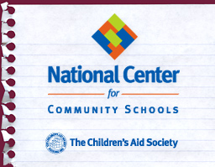

NCCS Holds 2nd Community Schools Fundamentals Conference in NYC
New YorkNY | Dec 14 2012
On December 5 and 6, 2012, over 160 community schools practitioners from 16 U.S. states and Canada, representing 40 cities attended the second Community Schools Fundamentals Conference in New York City.
Over two days, participants attended plenary sessions and workshops designed specifically for those new or relatively new to community schools and organized around the four capacities of effective community schools: Comprehensiveness, Collaboration, Coherence and Commitment. Staff from the CAS National Center for Community Schools (NCCS) shared lessons from over 20 years of practice in New York City and 18 years of national and international capacity building. In addition, conference faculty included colleagues from NCCS’s technical assistance satellites from the Community Learning Centers in Cincinnati, Oh, and the SUN Schools in Portland, OR, as well as a former Principal from Port Chester, NY, all of whom shared their considerable expertise with participants. Study visits to mature CAS community schools concluded the conference.
Participants left with a deeper understanding of the four capacities and having explored important issues that many schools and communities struggle with, including chronic absenteeism, parent engagement and school climate – to name just a few. A unique aspect of the conference is that it provides the opportunity to network and learn from colleagues who are at similar levels of development.
Increasingly, policymakers, educators, human service leaders and funders are recognizing the importance of addressing the learning side of the teaching-and-learning equation. That, of course, is exactly what the community schools strategy is designed to do and on what this conference was focused.
NCCS staff is now considering requests from colleagues in the field to take the Community Schools Fundamentals Conference on the road. Stay tuned for further developments -- Fundamentals may be coming to a town near you soon.

