A health care drought ends in Sayler Park
Anne Saker , asaker@enquirer.com10:03 a.m. EST December 1, 2016
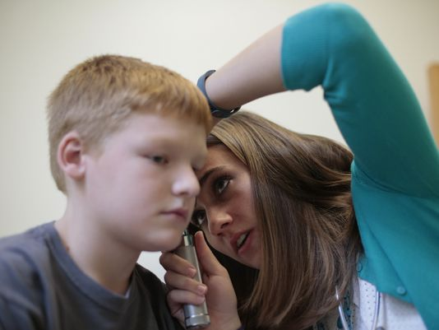
(Photo: The Enquirer/Kareem Elgazzar)
For at least a decade, when people in Sayler Park needed a doctor, they had to go north “up on the hill” to a West Side hospital, Jackie Litchfield Apted said.
But a few weeks ago, the drought ended as Mercy Health, in collaboration with the city of Cincinnati, started operating a health center inside the neighborhood’s elementary school.
“It’s so wonderful to come here. We are so thankful, you don’t know,” said Apted, a fourth-generation Sayler Park resident and president of the neighborhood’s village council.
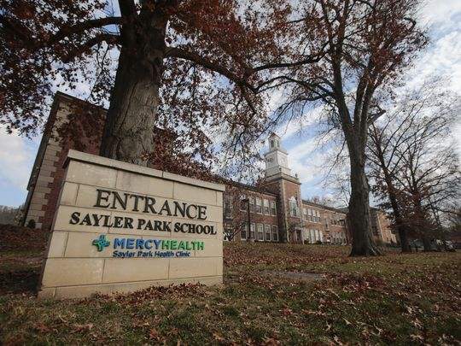
As part of the city's broad initiative to turn local schools into community hubs, Mercy Health worked with Cincinnati Public Schools, the Cincinnati Health Department and the Community Learning Center Institute to take on the project of bringing medical care to Sayler Park, Mercy Health spokeswoman Nanette Bentley said. And although the health center operates inside the school, it is open to the public.
The Sayler Park Health Clinic is the fourth school-based facility that Mercy Health has opened in the past three years in Cincinnati schools. Its three other centers operate in Mount Washington, Silverton and College Hill. The soft opening of the Sayler Park center was Nov. 14 and a ribbon cutting ceremony celebrating the opening is planned Friday.
Rachael Doll, a family nurse practitioner, is the permanent health care provider at the Sayler Park center. So far, she has provided care to more than two dozen students, the school’s adult staff and area residents.
“This is a big responsibility, but I’m ready to take it on,” she said. “I want to make sure the kids have access to health care and that the community has access.”
Sayler Park Elementary Principal Jamie Sowders said he is delighted with the center. “If a child needs health care, sometimes they can be out of school for two, three days, even a week,” he said. “When we can treat right here at school, the children miss less instruction.”

